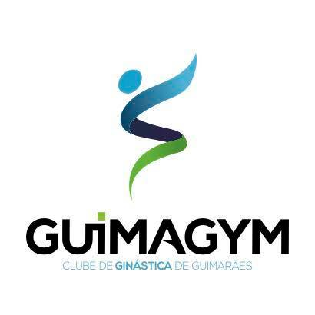
GUIMAGYM CUP 2020
International tournament in rhythmic gymnastics
GUIMARÃES / PORTUGAL
17-19 APRIL 2020

ACCOMODATION FORM

DEADLINE: 15.03.2020

FEDERATION |  | Team/Club:
 |  | Contact person:
 |  | Phone:
 |  | E-mail:

ROOM  Nº | LAST NAME,  First name | Function | Room type | Arrival day |  | Departure day | Price per person/night | # of nights | Total
GRAND TOTAL

Please, send to:
guimagymcup@guimagym.pt

___________________________________ __________________________________
(Place and date) (Signature & name)

Send before 15.03.2020

